|  |
| --- |
| **Karan Arora**  **R.L. Institute M: 9416974837**  **Class : X**  **Chapter : 12**  **“ELECTRICITY”** |

**Worksheet – 1**

**Name = ……………………… Date = ………………………………**

1. What is the maximum resistance which can be made using five resistors each of (1/5) Ω ?

|  |  |  |  |
| --- | --- | --- | --- |
| a) (1/5) Ω | b) 10 Ω | c) 5 Ω | d) 1 Ω |

1. What is the minimum resistance which can be made using five resistors each of (1/5) Ω ?

|  |  |  |  |
| --- | --- | --- | --- |
| a) (1/5) Ω | b) (1/25) Ω | c) (1/10) Ω | d) 25 Ω |

1. When a 4 V battery is connected across an unknown resistor, there is a current of 100 mA in the circuit. The value of resistance is :

|  |  |  |  |
| --- | --- | --- | --- |
| a) 4 Ω | b) 40 Ω | c) 400 Ω | d) 0.4 Ω |

1. The resistivity of a conductor increases with :

|  |  |
| --- | --- |
| a) increase in temperature | b) increase in cross-sectional area |
| c) decrease in length | d) decrease in cross-sectional area |

1. Three resistances of 2 Ω , 4 Ω and 8 Ω are connected in series. Their equivalent resistance is :

|  |  |  |  |
| --- | --- | --- | --- |
| a) 10 Ω | b) (8/7) Ω | c) 14 Ω | d) between 2 Ω & 8 Ω |

1. A device is used to measure current , voltage and resistance is called :

|  |  |  |  |
| --- | --- | --- | --- |
| a) voltmeter | b) ammeter | c) AVO meter | d) ohm meter |

1. One kilo watt hour is equal to

|  |  |  |  |
| --- | --- | --- | --- |
| a) 36 X 105 J | b) 36 X 103 J | c) 36 X 10 – 5 J | d) 36 X 10 – 3 J |

1. Ten identical wires each having a resistance of one ohm are connected in parallel. The combination will have a resistance of

|  |  |  |  |
| --- | --- | --- | --- |
| a) 10 Ω | b) 1 Ω | c) 0.1 Ω | d) 0.01 Ω |

1. The unit of resistivity is

|  |  |  |  |
| --- | --- | --- | --- |
| a) ohm | b) ohm metre2 | c) ohm-metre | d) ohm per metre |

1. The resistivity does not change if

|  |  |
| --- | --- |
| a) the material is changed | b) the temperature is changed |
| c) the shape of the resistor is changed | d) both material and temperature are changed |

1. Bulb B1 and B2 are exactly identical. When the key K is pressed, the reading of the ammeter will

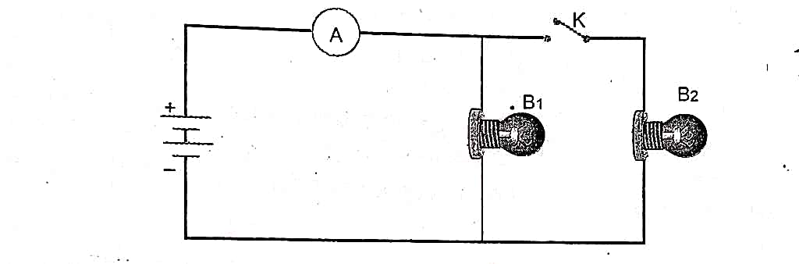

|  |  |  |  |
| --- | --- | --- | --- |
| a) remain unchanged | b) be doubled | c) be halved | d) becomes four times |

1. Define current. Give its SI unit.

____________________________________________________________________________________________________________________________________________________________________________________________

1. Define resistance. Give its SI unit.

____________________________________________________________________________________________________________________________________________________________________________________________

1. Write the function of voltmeter in an electric circuit.

____________________________________________________________________________________________________________________________________________________________________________________________

1. A current of 0.5 A is drawn by a filament of an electric bulb for 10 minutes. Find the amount of electric charge that flows through any point of the circuit.

______________________________________________________________________________________________

1. A current of 5 A is flowing through a resistor of 15 Ω . Calculate the potential difference between the ends of the resistors.

_____________________________________________________________________________________________

1. A wire of resistance is 5 ohm is bent in the form of a closed circle. What is the effective resistance between the two points at the ends of any diameter of the circle?

______________________________________________________________________________________________

1. What is the commercial unit of electric energy? Represent it in terms of joules.

______________________________________________________________________________________________

1. Define 1 ampere?

____________________________________________________________________________________________________________________________________________________________________________________________

1. Define 1 Volt?

____________________________________________________________________________________________________________________________________________________________________________________________

1. Write formula of resistance.

______________________________________________________________________________________________

1. Write units of resistivity.

______________________________________________________________________________________________

1. A 24 volt battery is connected to the arrangement of resistances as in figure. Calculate (i) the total effective resistance of the circuit, (ii) the total current flowing in the circuit.

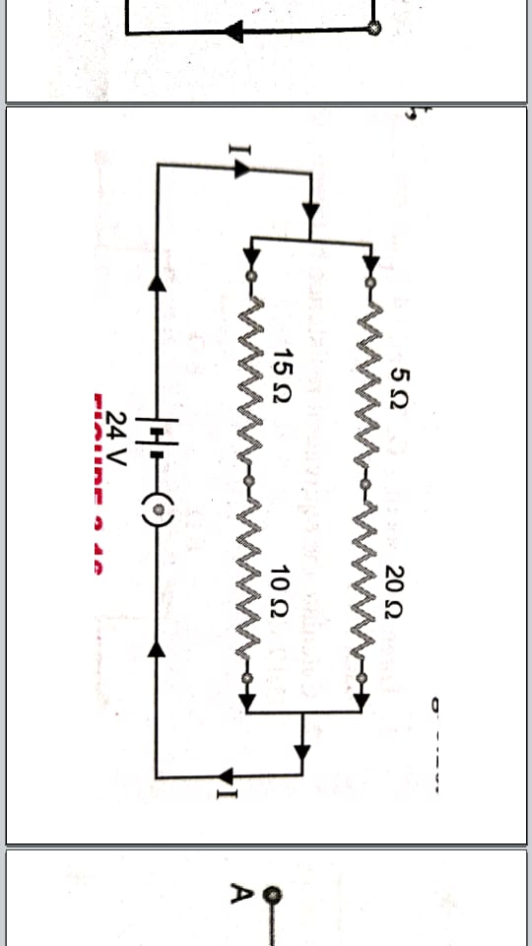

_____________________________________________________________________________________

1. Calculate the equivalent resistance between the points A and B in the circuits shown in figure.

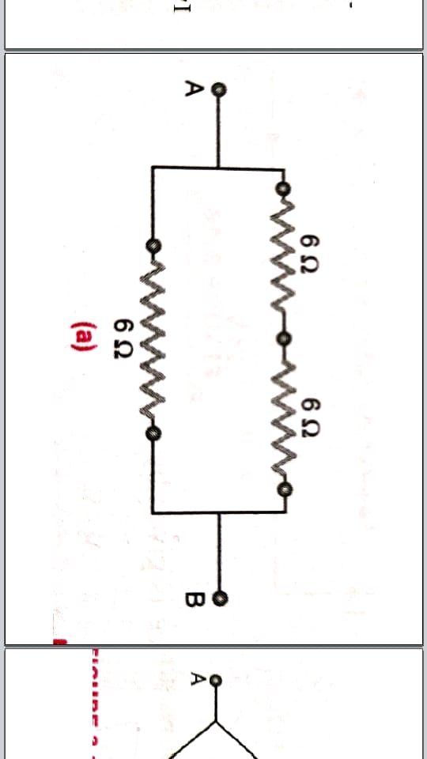 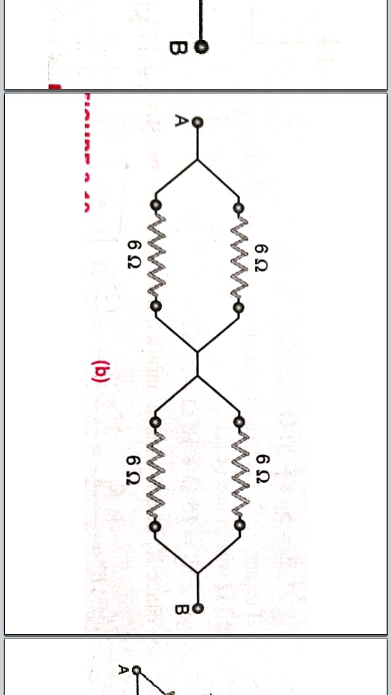

_____________________________________________________________________________________

**True / False**

1. Three resistors of 2 Ω , 3 Ω and 6 Ω can be connected to give an equivalent resistance of 4 Ω .
2. Electric current flows in a direction opposite to the flows of electrons.

Remark Parent’s signature Teacher’s signature